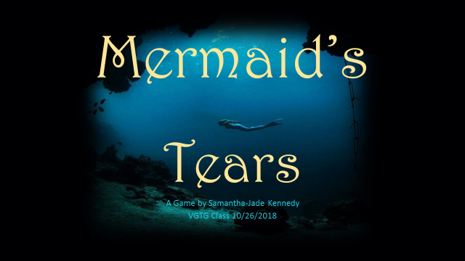  
  
Consoles and PC  
8+  
Teen  
Projected release date 2022

**Game Outline**

Start out in a peaceful kingdom under the ocean, you’re friends with the prince/princess (choose in set up – either way can lead to a romantic relationship at the end) and are on your way to visit them when darkness descends on the palace. Your friend, their family & the whole palace are locked in a massive block of ice and you are off on a quest to restore them.

First off to the wise sea witch’s cave, she will tell you to follow the darkness and the destruction it’s caused, only at the source will you find the cause and defeat it. Just as you are leaving she will tell you to open a chest and take a weapon to defend yourself, choose a sword, a magic trident or a spear. She will give you the basics of whichever weapon you choose.

Explore the ocean, looking for signs the darkness has passed this way. When you encounter an area where the darkness has caused problems you can stop to help the being effected. Helping others will grant you rewards that will make your mission a little easier, failing to help will make it much more difficult, as those you fail to help may turn on you in anger, now or on your journey back. Some creatures can communicate across vast distances of the ocean and may call others to block your progress until you help them.

Speak with friendly sea creatures, battle less friendly ones like sharks and sea monsters.

Eventually you will come to a massive cave deep under water that the darkness seems to be emanating from, at the end of the cave will be a massive squid man/monster who has been trying to take over the underwater world with an ice scepter.

Once he is defeated you travel back to your home, with help from various creatures you have helped, when you finally make it you use the scepter to save your friend and the royal family. There is an option to marry your friend and rule the kingdom for your bravery, will you take it?

The game is mostly divided by quests, to complete various quests you will need to solve a puzzle, find a solution to a physical problem or fight a boss to proceed to the next quest or area.

Along the way you will encounter Challenges such as: (in no particular order)

* Underwater volcanoes - enough said yes?
* Thermal vents of super-heated water, they will burn you and should be avoided.
* Noxious gas vents, such as Sulphur again should be avoided as they will drain your health
* Pillow lava, spreads a bit differently than lava on dry land, watch it be sure it doesn’t sneak up on you, may fill in areas below you in some boss areas
* Seaweed that may tangle around you – use your weapon to clear your way or free yourself
* Unfriendly creatures like sharks can also be problematic, use your weapon to discourage them.

**Merchants**

Throughout the game you will encounter merchants and stores that can sell you various items.

* Potions – some will heal you, some will be distilled skill points, some rarer potions will allow you to grow or shrink
* Facemask will help you breath in areas of polluted water
* Spell tablets teach you additional magics
* Weapons, to round out your collection
* Food, such as sea fruits and prepared fish.

**Gold, Hit Points, Mana and Skill Points**

* There is a currency system in game based on gold (looks like a small gold shell) gold is acquired by completing quests, found in chests, and dropped by defeated enemies.
* Hit points show your total health, when it reaches 0 you have died –potions and food to recover
* Mana does not have a limit, some higher level spells take longer to charge/use – spells are found as items in chests or as rewards for good deeds
* Skill points are used to increase your proficiency with various skills, they can be used towards health, physical or magical abilities. Obtained by overcoming challenges and enemies.

**Character**  
Main character is your avatar, a merman or mermaid, Default names Melody and Riptide respectively.

Names, and characters are as customizable as we can make them without causing issues with the rest of the system.

You have grown up around the palace, friends with the heir to the throne.

Your home is a dark silver coral tower you will be able to explore.

There may be a reference from your friend bout the fun you used to have pulling pranks on royal advisors or riding dolphins when you were children but that’s about all the backstory you get.

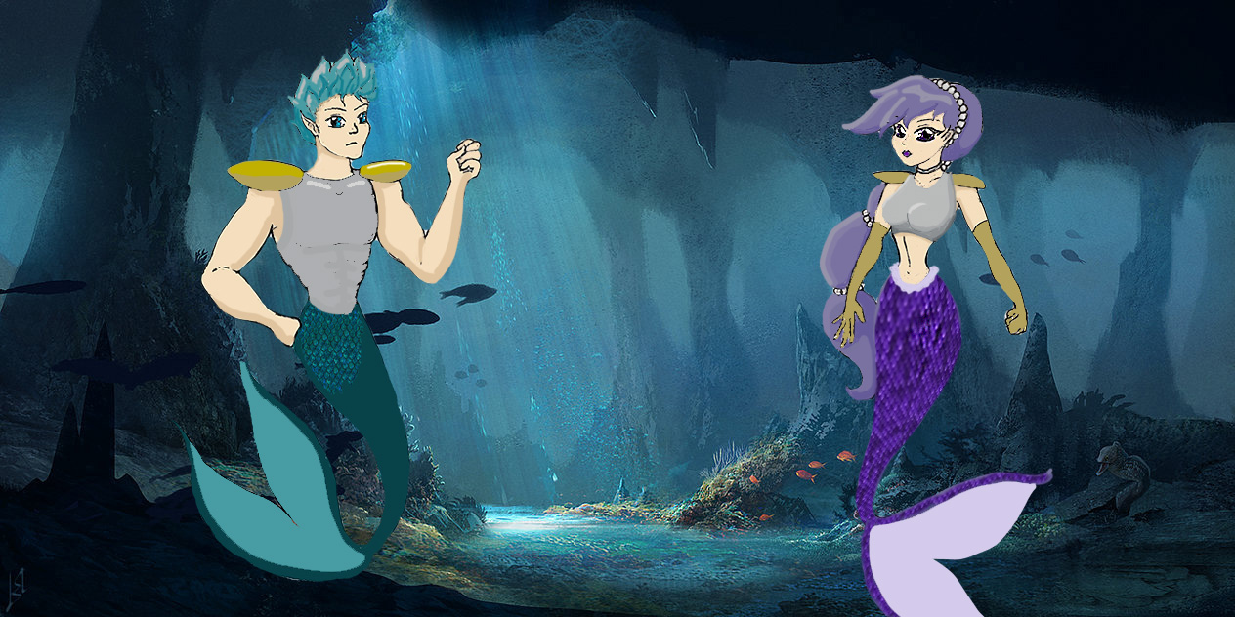  
   
**Game Controls**

Playstation 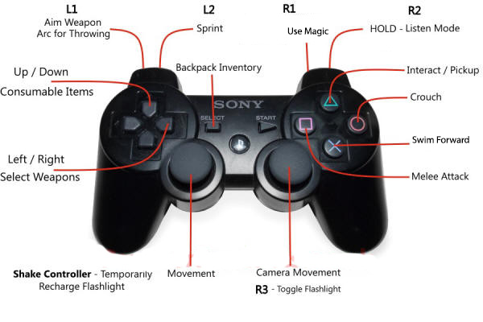

Xbox

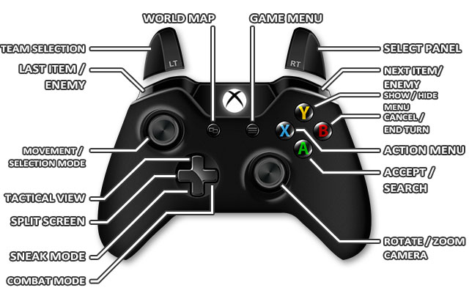

PC

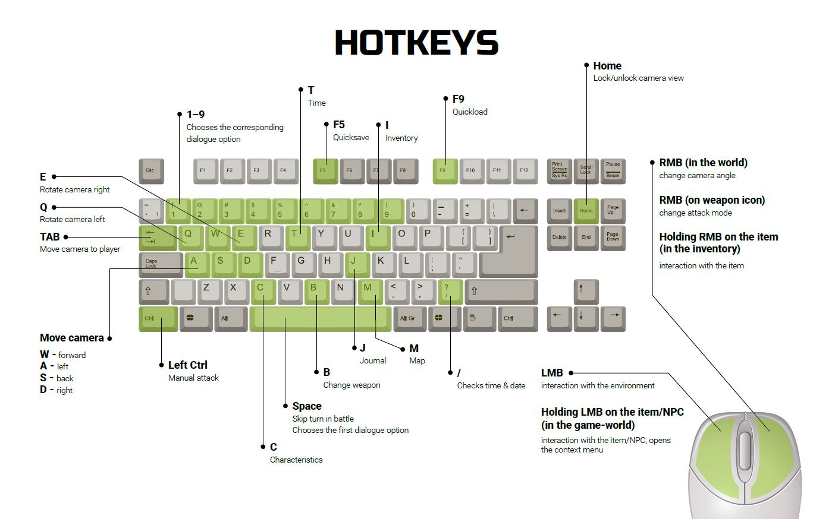

**Game World**

Mostly under the sea, explore caves, coral reefs, and all the other cool things found on the ocean floor.

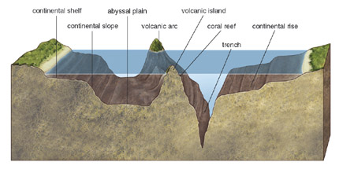



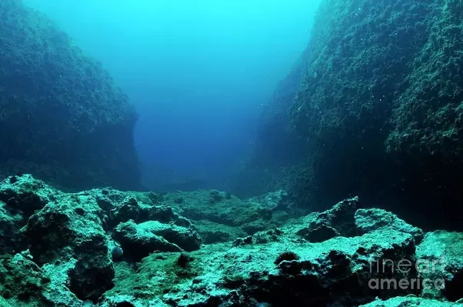

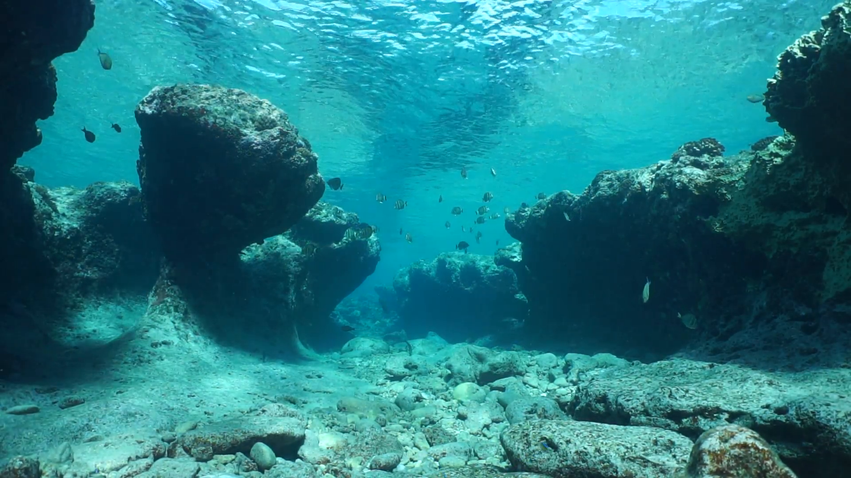

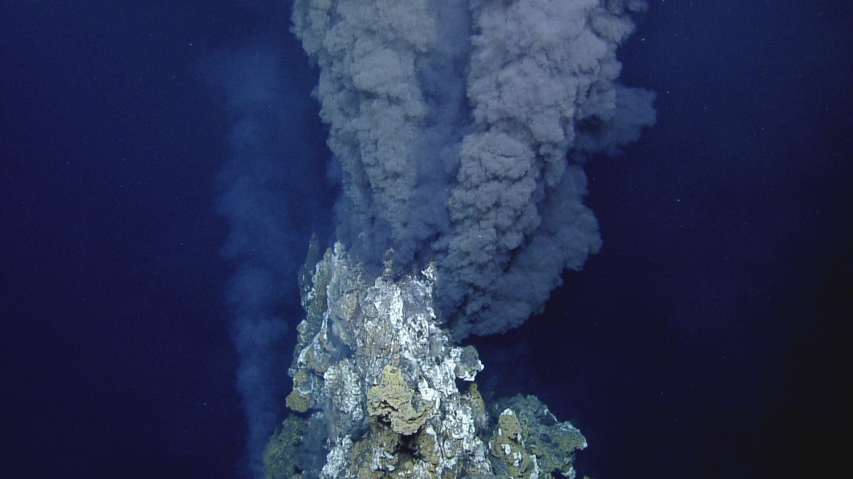

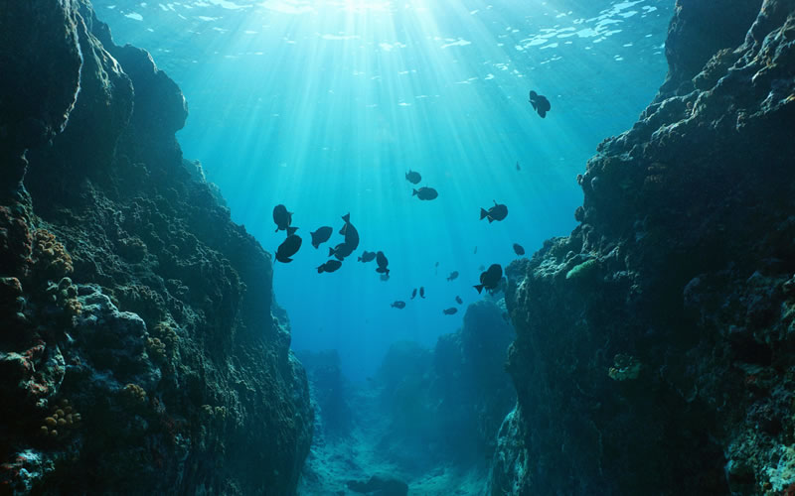

Eventually you can unlock the ability to walk on land and you can explore a number of islands, more islands available as DLC packs.

**Game Experience**  
As the game begins we see vast bight ocean filled with color and life, things seem peaceful.

The game progresses through to dread, shock and horror as the first signs of trouble appear and the palace is frozen.

Once the journey begins the feeling should turn to determination.

At the climax a crescendo and afterward something joyful.

Music for all of these parts of the game should be instrumental, and match the feel of the moment. An underwater or island sound to it, at least for the happier portions would be ideal.

**Shell Menus**

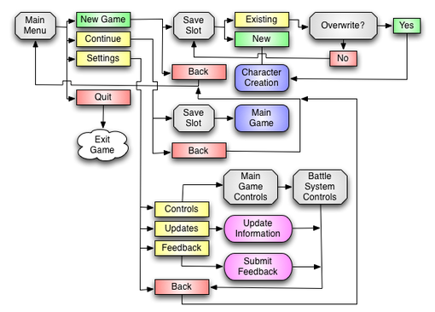

Menu Skills Use skill points

Items Food Weapons Clothing Misc

**Collectables**  
Along the way there will be sunken ships and treasures, collect

*Sea shells of unique design (36)

Reward is ultimate armor.

*Sea flowers (36)

Reward is a special potion to increase all skill points by a larger amount than anything else in the game

*Rainbow Pearls (9 red, orange, yellow, green, blue, purple, black, silver, gold)

Reward is a special dye pack for customization (works on hair/clothing)

## *Rare Jewels (Blue Diamond, Alexandrite, ruby, sapphire, emerald, Jade, Black opal, Moonstone, Fire Opal) (9)

## Reward – Gem of transformation, walk on land

*Special treasures. (9) Each of the treasures is a reward of its own and require solving a puzzle of some sort to acquire. Mostly these will be given by the more obscure creatures that need your help. (In the order they will appear in the game)

* Diamond Compass,

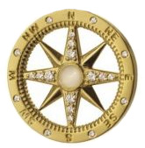This will help you find your way around - Found right at the beginning by helping a dolphin free his tail from the ice surrounding the palace, you will need to use rocks to carefully chisel him out – mini game)

* Glowing Coral,

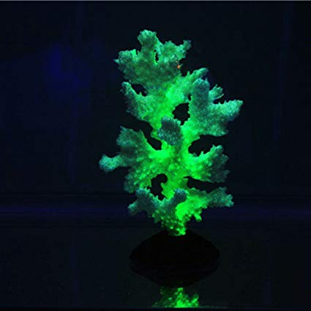

Will light your way (found not far from the sea witch, by moving a block of ice that has trapped a baby Axolotl Salamander.)

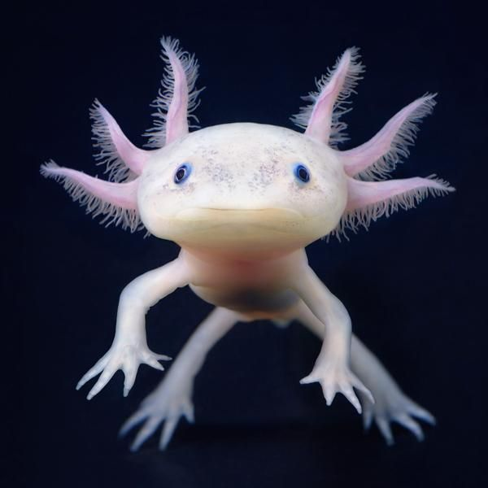

* Amulet of Understanding, will allow you to understand everyone, regardless of species. (Found by helping a cuddle fish tangled in sea weed)

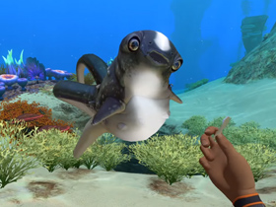

* The Flaming Gauntlets, can melt small amounts of the Dark Ice (roughly up to the size of a minivan) and will keep you from freezing. (Found by helping a sea dragon clear a rock blocking the entrance to his home)

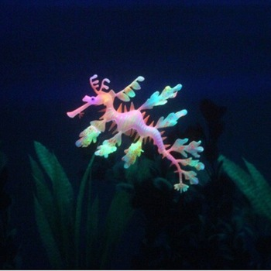

* Philosophers Crown, allows you to think through problems in a new way (unlocks a more focused view for mini games and puzzles)
* Echo’s Earrings, allows you to hear smaller or more distant sounds, makes creatures looking for help easier to find.
* Celestial Spy glass, allows you to see details farther away
* Lazarus’ Armband, heals damage over time
* Serenade Music box, the last, most difficult to find and acquire treasure puts low level enemies to sleep while it pays, leaving the more difficult enemies a little slower. (does not affect bosses)

**Enemies**

* Main Boss, The monster Leareth, tentacles must be severed
* Hydra, remove all heads at once
* Sharks
* Leviathan, trip him then attack eyes
* Poisonous creatures, mostly use weapon / heal poison

**Achievements**

* Complete all quests
* Marry the princess (prince)
* Find all of collectables (individual acheivements for each set and a major achievement in collecting the entirety of all sets.)
* And many more

Online muti-player available after visiting the sea witch, invite up to 3 other players to join you in your quest

Monetization  
Actual game will sell for a projected 59.99 USD,

DLCs available will include:

More Areas to explore with special collectables, at least one unique item and quests. Should be priced around 39.99 USD each

Customization Items, available only as DLC will be priced variously as seems to suit the individual item.